Name: Bayo Awoh
Course: IT 3883
Date: 03/26/2025

Program A
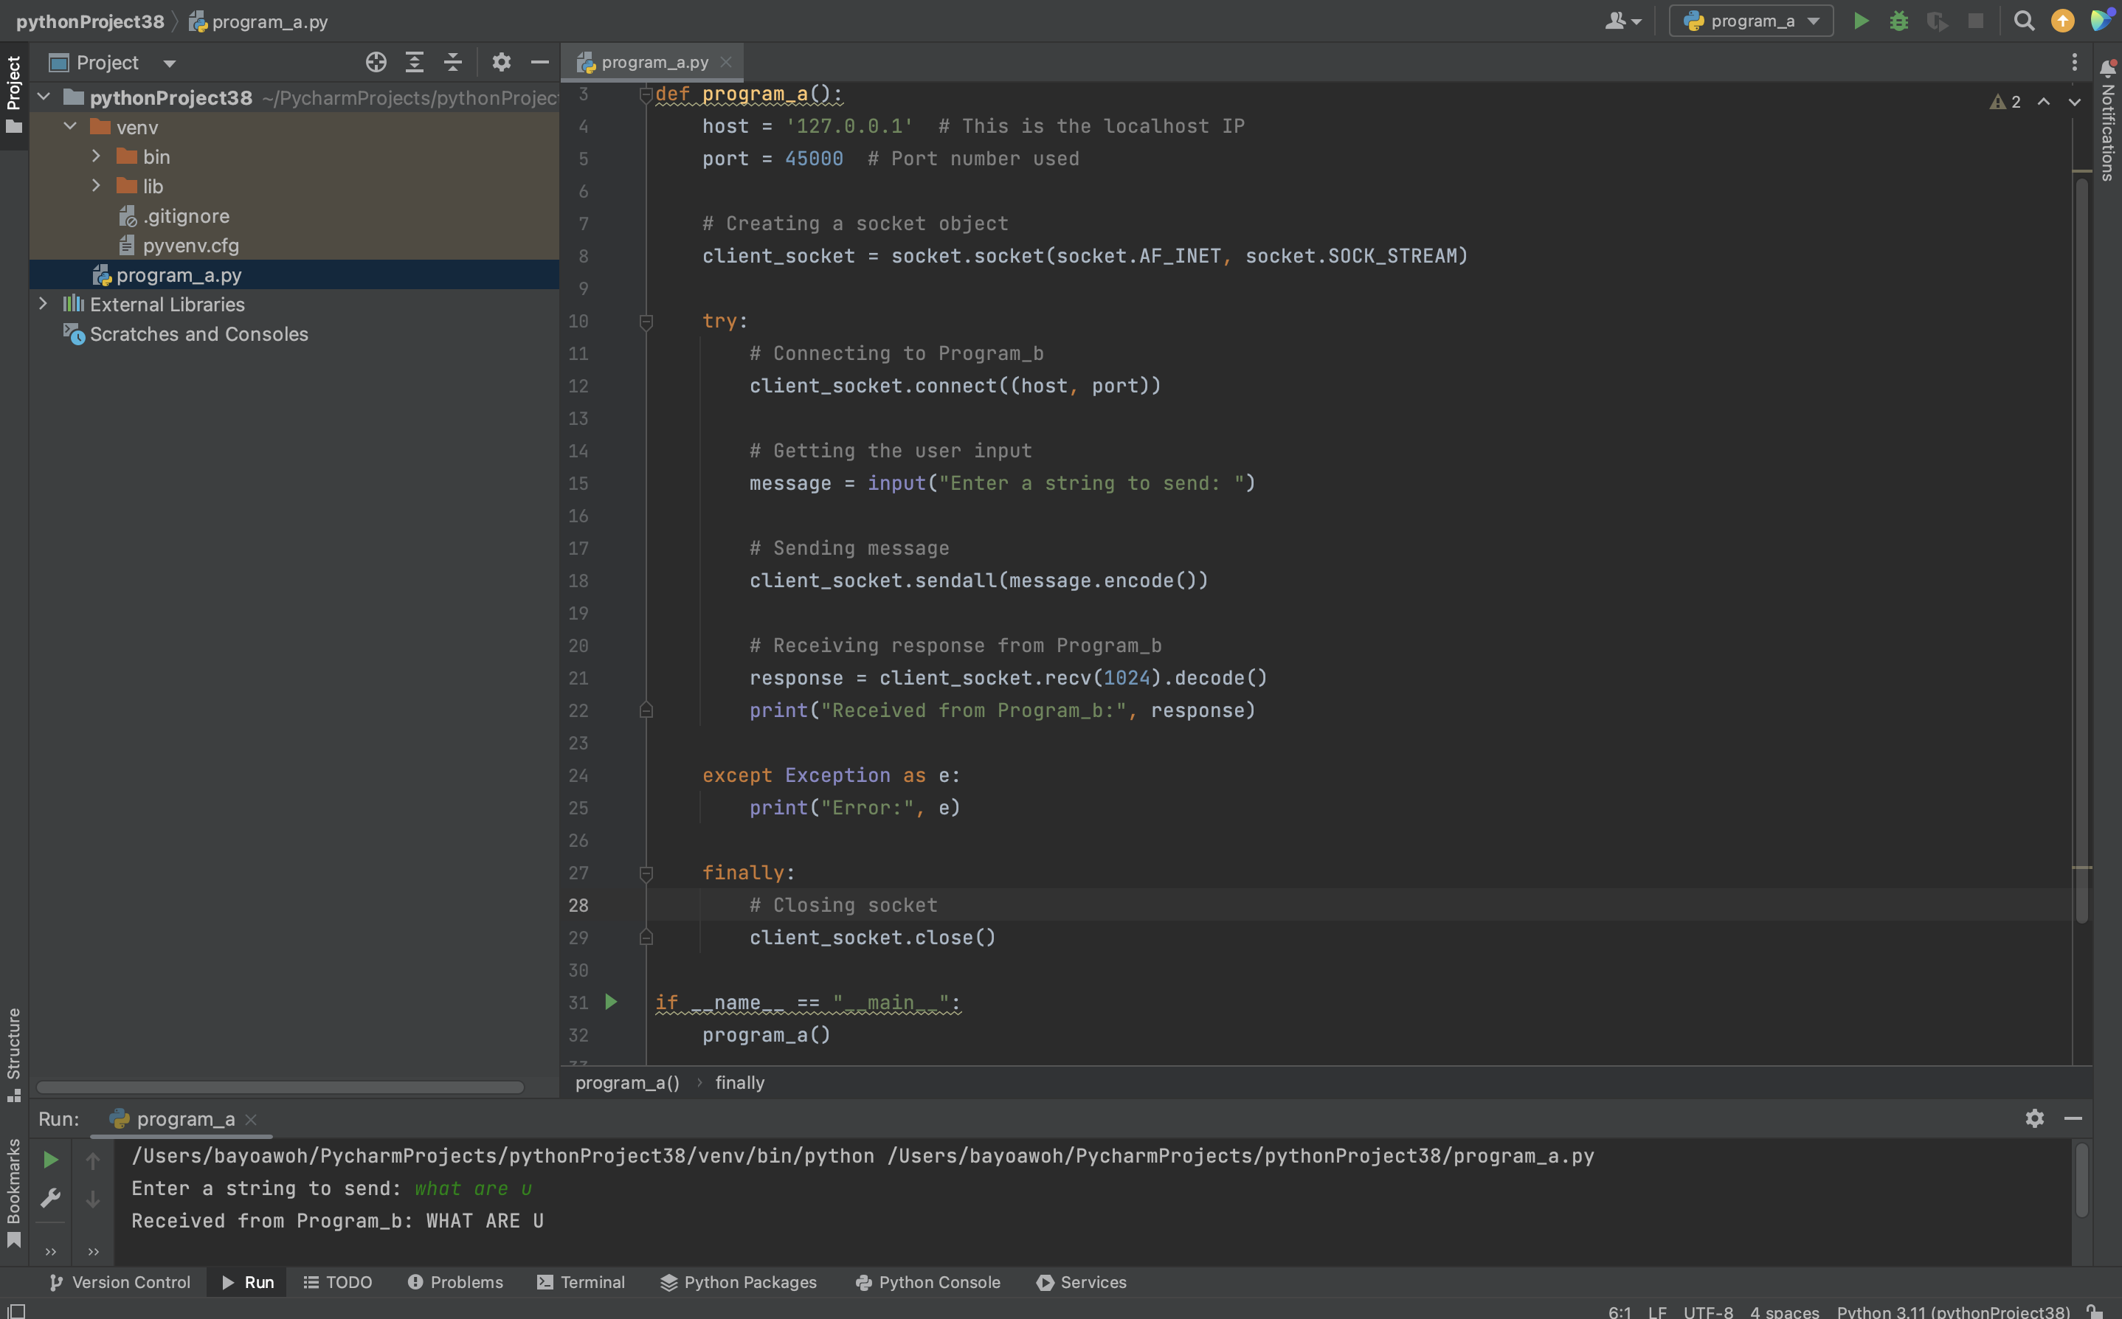

Program B

